**Ideation Phase**

**Brainstorm & Idea Prioritization Template**

|  |  |
| --- | --- |
| Date | 12 April 2025 |
| Team ID | SWTID1743607402 |
| Project Name | ShopEZ: E-commerce Application |
| Maximum Marks | 4 Marks |

**Brainstorm & Idea Prioritization Template:**

Brainstorming provides a free and open environment that encourages everyone within a team to participate in the creative thinking process that leads to problem solving. Prioritizing volume over value, out-of-the-box ideas are welcome and built upon, and all participants are encouraged to collaborate, helping each other develop a rich amount of creative solutions.

# Step 1: Team Gathering, Collaboration and Select the Problem Statement

Our team came together to address the challenges faced by online shoppers and small-scale sellers. After discussion, we selected the following problem statement:  
  
‘Online shoppers struggle with complex user interfaces and lack of trust in sellers, while small-scale sellers face difficulty managing their digital presence and reaching potential customers.’

# Step 2: Brainstorm, Idea Listing and Grouping

Ideas generated during brainstorming session:

- Simple and clean UI for effortless navigation  
- Verified seller badges to build trust  
- Smart search and filtering capabilities  
- Personalized recommendations using AI  
- Real-time order tracking for buyers  
- Seller dashboard with performance analytics  
- Easy product upload and inventory management for sellers  
- Integration of secure and fast payment gateway  
- Customer reviews with image/video support  
- Multi-language support for regional access

# Step 3: Idea Prioritization

Top priority ideas based on user value and ease of implementation:

Clean and intuitive UI (High Value, Easy to Implement)  
2. Seller dashboard for easy inventory and order tracking (High Value, Moderate Difficulty)  
3. Verified seller system (High Value, Moderate Implementation Effort)  
4. Personalized product recommendations (Moderate Value, Advanced Implementation)  
5. Smart search and filters (High Value, Easy to Moderate Implementation)

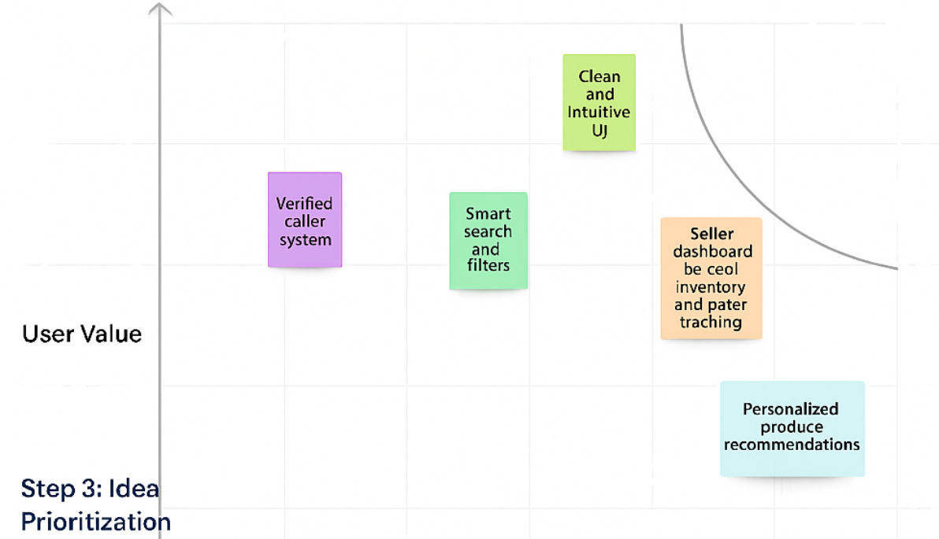

**Visual Representation of Key Features**

Empathy Map Visualization:

